**S.I.M ERP Software Architecture**

**19 Sep 201****9**

By ….

1. **Architecture**

Angular.io 6.0.8

Web

Android

IOS

C# ASP.Net 4.6.1

DB (SQLServer)

QuickBooks APIs

Google APIs

QuickBooks APIs Client

Google APIs Client

AWSSDK

DAO

Jobs

Employees

Equipments

Etc…

Restful APIs

1. **Proposed Technologies**

* Client: Hybrid framework with Angular.io + Material (so we can release both Web and Mobile apps in a shorter timeline)
* Server: .Net C#
* Database: SQL Server
* File Storage: AWS - S3

1. **Hosting Solutions**
   1. **Testing Environment**

* Server: local server (SMS datacenter)
* Database: SQL Server
* File Storage: Local
* Load Balancer: No need at the moment
  1. **Staging Environment (for integration test and approval before production released)**
* Server: AWS - EC2 with Windows Server installed
* Database: Amazon RDS – SQL Server
* File Storage: AWS - S3
* Load Balancer: No need at the moment, will consider later when/if we need performance testing for the system.
* *Notes: need AWS account* 
  1. **Production Environment**
* Server: AWS - EC2 with Windows Server installed
* Database: Amazon RDS – SQL Server
* File Storage: AWS - S3
* Load Balancer: AWS - Elastic Load Balancing

1. **Pre-requisitions**
   1. **Create AWS account. Please refer link:** https://portal.aws.amazon.com/billing/signup?nc2=h_ct&redirect_url=https%3A%2F%2Faws.amazon.com%2Fregistration-confirmation#/start
   2. **Buy services from Amazon:**

After creating AWS account and verifying credit card then please login and go to Services page:

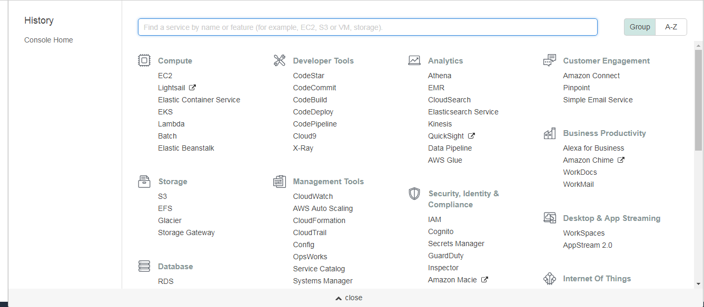

And then select and registry some services as below:

* AWS - EC2 with Windows Server is installed
* Amazon RDS – SQL Server
* AWS - S3
* AWS - Elastic Load Balancing (we only use it once we have more than one server)

1. **Tools and 3rd parties**
   1. **Development tools:**

* IDE: Visual studio 2017
* SQL Server client: SQL Server Management Studio or Heidi
  1. **3rd parties:**
* Google APIs: Google APIs Client
* QuickBooks APIs: Intuit SDKs, Node-QuickBooks, QuickBooks SDK

**6. Deployment diagram**

QuickBooks Desktop Server

(AWS-EC2

Windows Server

.Net Framework 4.6.1)

QuickBooks Desktop 2017

QuickBooks SDK

(QBFC library)

QuickBooks Desktop APIs

Server Client

+Angular/material

+build tools

(AWS-EC2 Windows Server)

<<HTTPS>> Protocol

<<HTTPS>> Protocol

<<HTTPS>> Protocol

Load Balancer

(AWS - Elastic Load Balancing)

Google APIs

File Storage

(AWS - S3)

Database

(Amazon RDS – SQL Server)